**How Much is There to Eat?**

|  |  |  |
| --- | --- | --- |
|  | India | United States below  37°N Latitude |
| Land Area | 1,200,0002 | 1,200,0002 |
| Population | 1,002,142,000 | 92,000,000 |

With Ms. Cyr, we did a simulation of the population of two areas divided by the arable land. Here is the key:

1 Rice Cake = 50,000 MI2

1 Student = 45,000 people

If you think of an entire country as arable land and then subtract where you can’t have land, here is the result:

**Arable Landblocks**

|  |
| --- |
| **India Roadblock** |
| Himalayas 1/12  - 2 Rice Cakes |
| Thar Desert 1/12  - 2 Rice Cakes |
| S. Peninsula 1/3  - 8 Rice Cakes |

|  |
| --- |
| **USA Roadblock** |
| Plateaus 1/6  - 4 Rice Cakes |
| Dry Grasslands 1/4  - 6 Rice Cakes |
| Forests + Hills 1/6  - 4 Rice Cakes |
| Wetlands 1/12  - 2 Rice Cakes |

**Arable Land:**

**12 Rice Cakes Arable Land:**

**8 Rice Cakes**

India’s population divided by Southern USA population

arable land: .54 rice cakes per divided by arable land: 4

student. rice cakes per student.

The point of this activity was to calculate how much less food there was per person in India versus the southern USA, consisting of the following states: Kansas, Missouri, Texas, Florida, New Mexico, Oklahoma, Arizona, Louisiana, Mississippi, North Carolina, Georgia, Tennessee, Alabama, Arkansas, and South Carolina.

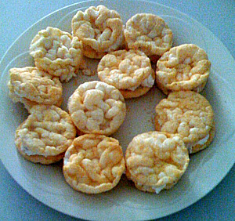

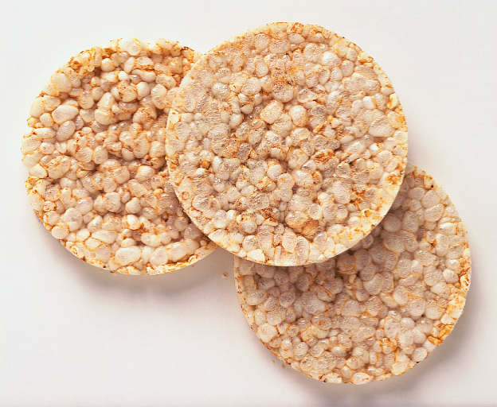People from India

**People from the USA**